Exp19.Create A Storage Service Using Any Public Cloud Service Provider (Azure/Gcp/Aws) And Check The Public Accessibility Ofthe Stored File To Demonstrate Storage As A Service.

Aim:
To Create A Storage Service Using Any Public Cloud Service Provider (Azure/Gcp/Aws) And Check The Public Accessibility Ofthe Stored File To Demonstrate Storage As A Service.

Procedure:
Step1: Open Azure And Goto Storage Accounts And Createstoroage Account
Step2: Enter The Resourc Groupand And Storage Account Nameand Review And Create And Click Th Create And Your Storage Account Will Be Deployed Sucessfully.
Step3: Our Storage Account Is Created.
Step4: Goto Static Website
Step5: And Enable And Enter Your Index And Error Html Files Names.
Step6: And Goto Storage Explorr(Review) And And Goto Blobcontainers And Web And Upload The Two Html Files Init
Step7: And Again Return To Static Website And Open The Primarylink And Your Web Page Is Created

Implementation:

Step1: Open Azure And Goto Storage Accounts And Createstoroage Account

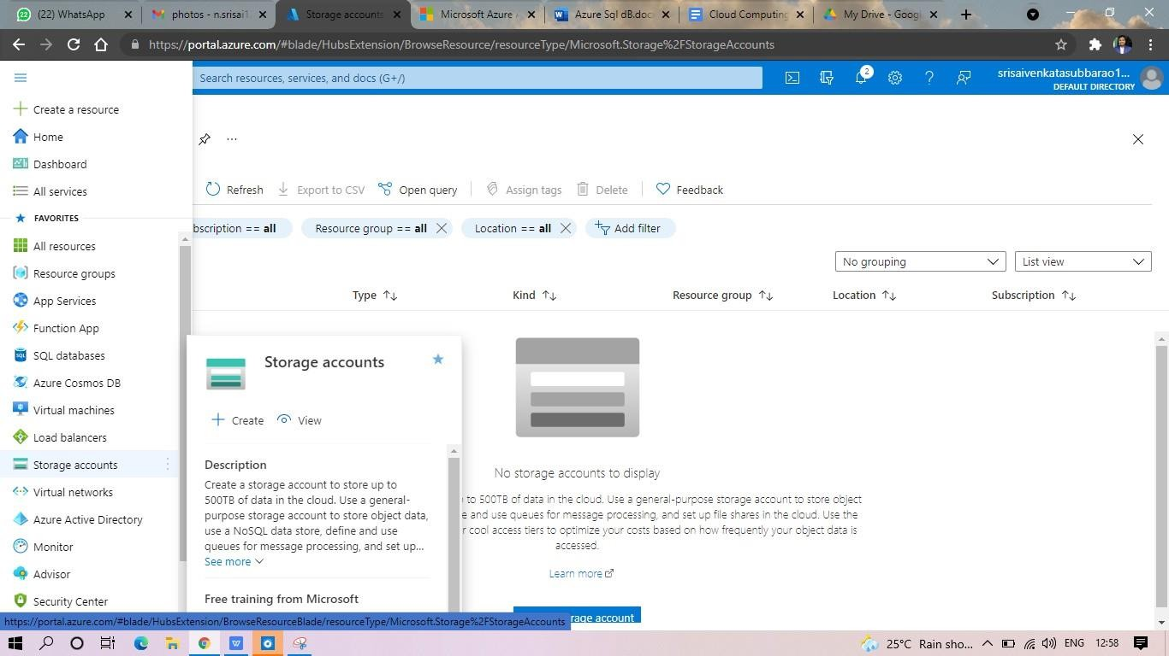

Step2: Enter The Resourc Group And And Storage Account Nameand Review And Create And Click Th Create And Your Storage Account Will Be Deployed Sucessfully.

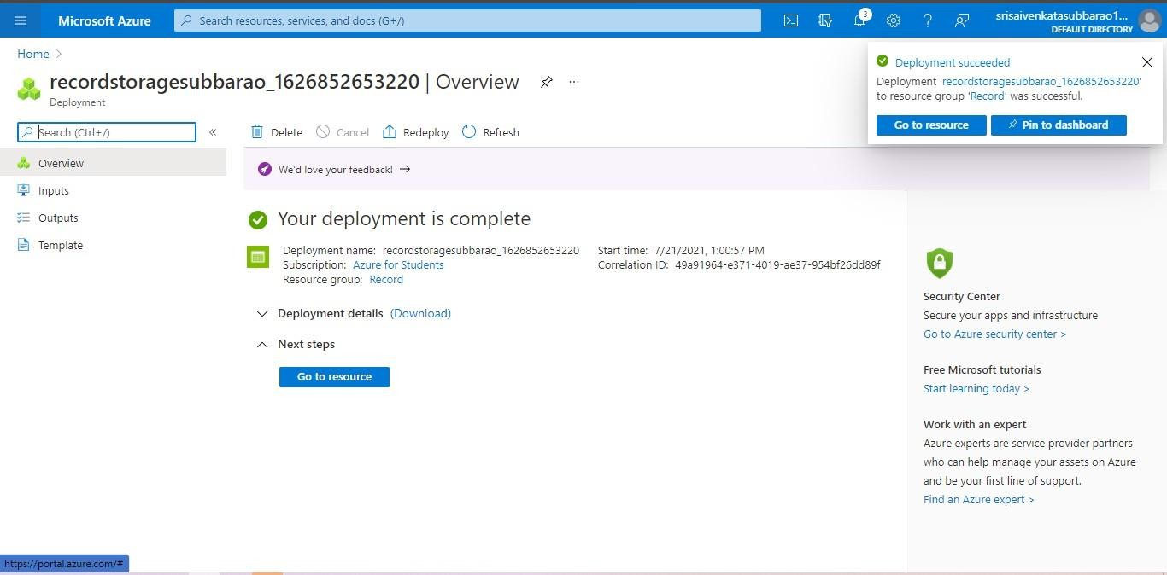

Stp3: And Our Storage Account Is Created.

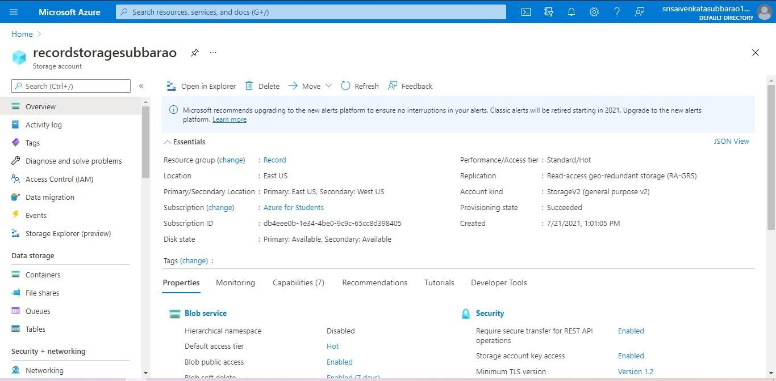

Step4: Goto Static Website

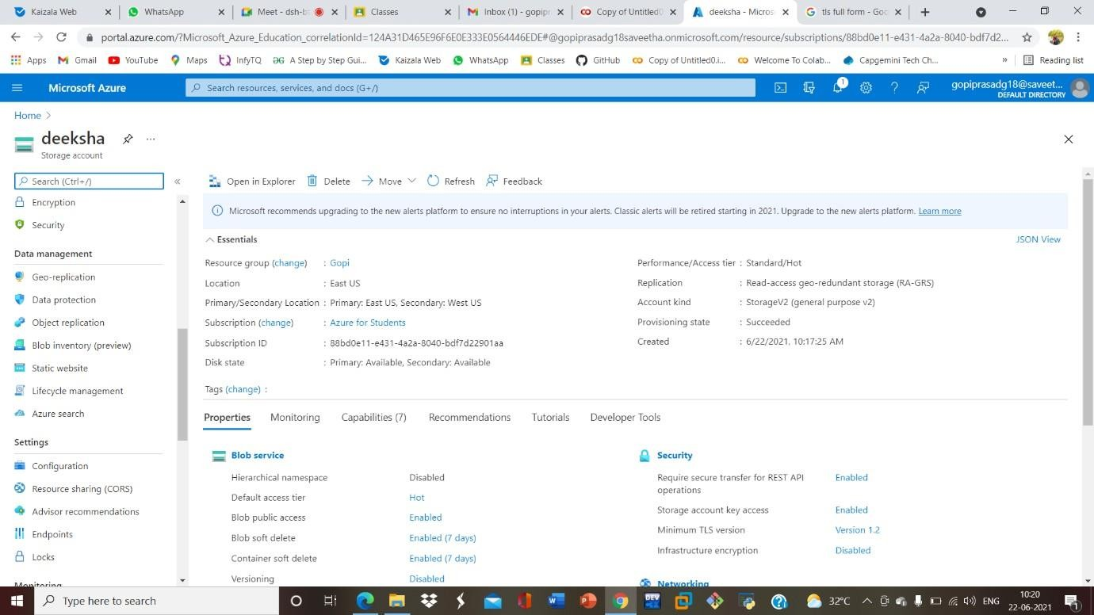

Step5: And Enable And Enter Your Index And Error Htmlfilesnames.
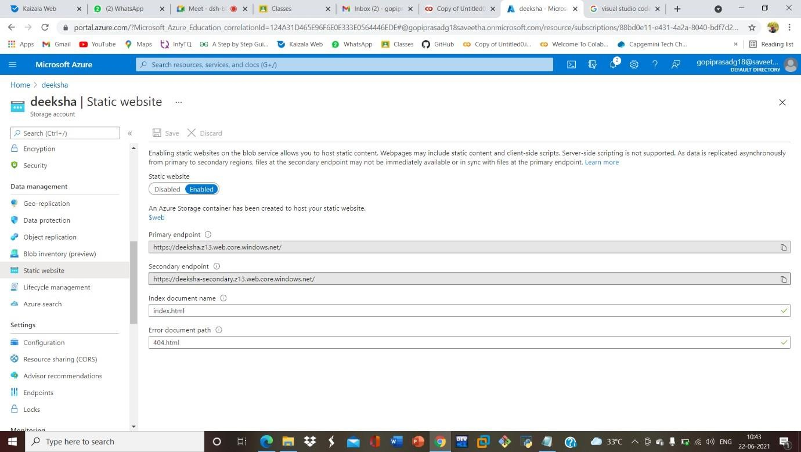

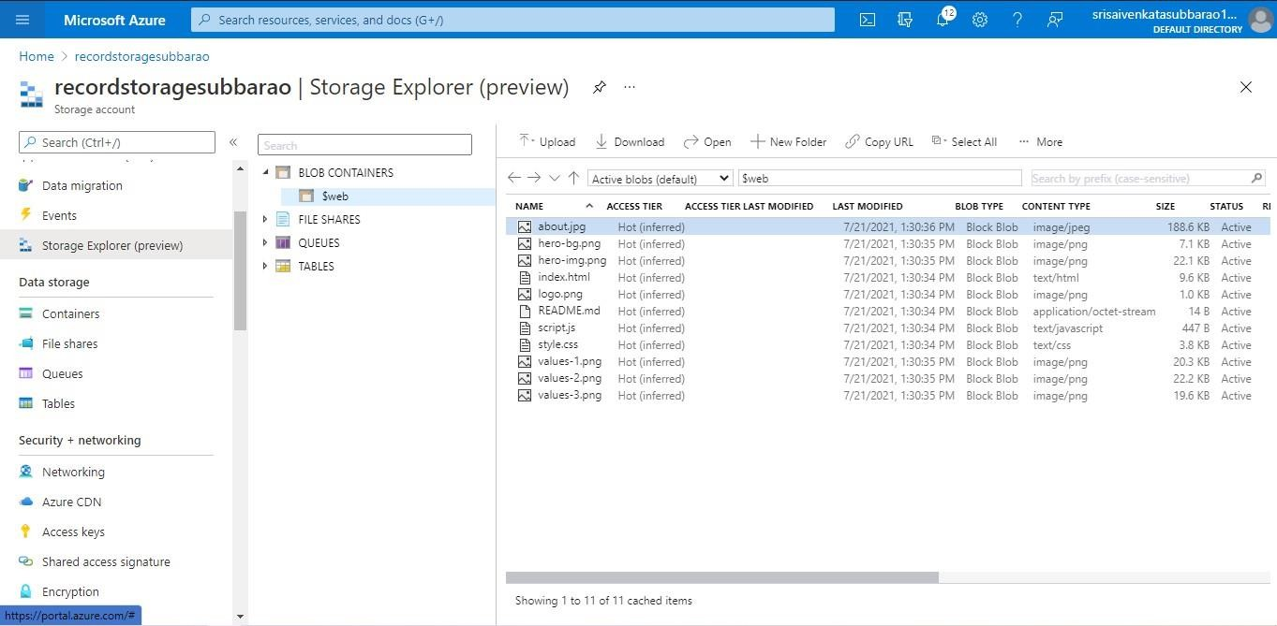
Step6: And Goto Storage Explorr(Review) And And Goto Blobcontainers And Web And Upload The Two Html Files Init

Step7: And Again Return To Static Website And Open The Primarylink And Your Web Page Is Created



Exp20.Create A Sql Storage Service And Perform A Basic Query Usingany Public Cloud Service Provider (Azure/Gcp/Aws) To Demonstrate Database As A Service (Daas)

Aim: Create A Sql Storage Service And Perform A Basic Query Usingany Public Cloud Service Provider (Azure/Gcp/Aws) To Demonstrate Database As A Service (Daas)

Procedure:
Step1: Goto Azure And Goto Sqldatabase.
Step 02: Now Create A Sql Databse
Step3: Select The Resource Groupand Enter The Servernamethat Applicable.
Step4: In Networking Select Allow Azure Services And Resources To Access This Server.
Step5: In Additional Settings Select Sample.

Step6:And The Sql Database Is Deployed
Tep7: Now Goto Query Editor.
Step8:Now Again Login To The Sqldatadatabase
Step9: Our Tables Will Shown And Type The Query To Excuted.

Implementation:

Step1: Goto Azure And Goto Sqldatabase.

Step 02:- Now Create A Sql Databse
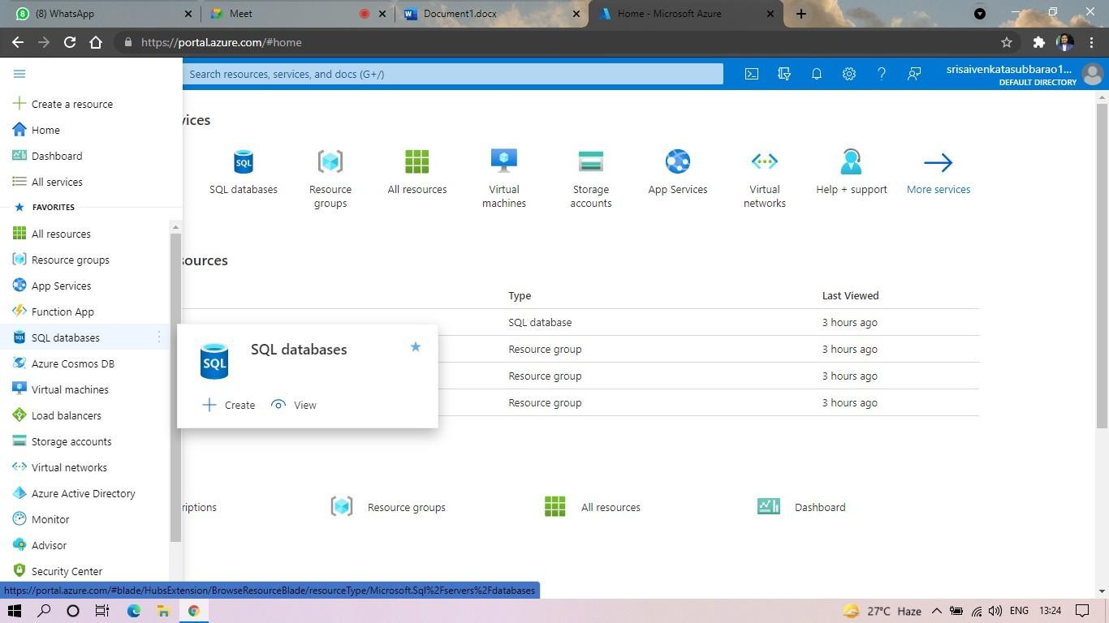

Step3: Select The Resource Group And Enter The Servernamethat Applicable.
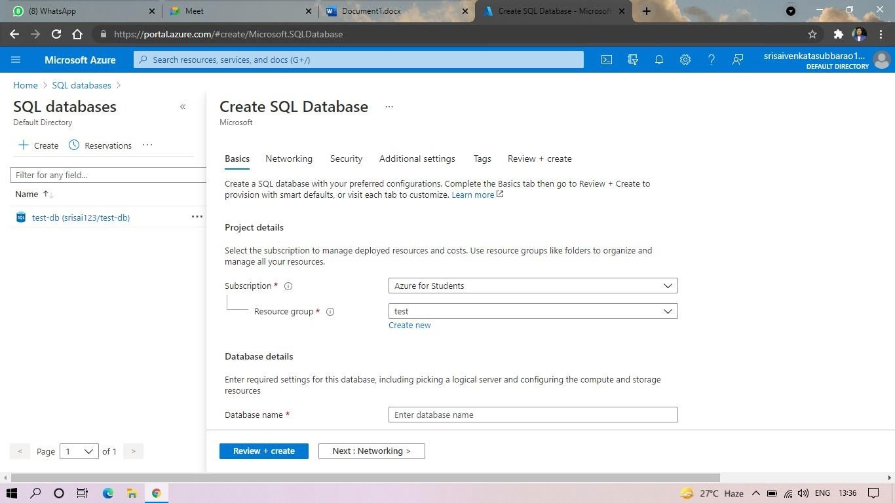

Step4: In Networking Select Allow Azure Services And Resources To Access This Server.
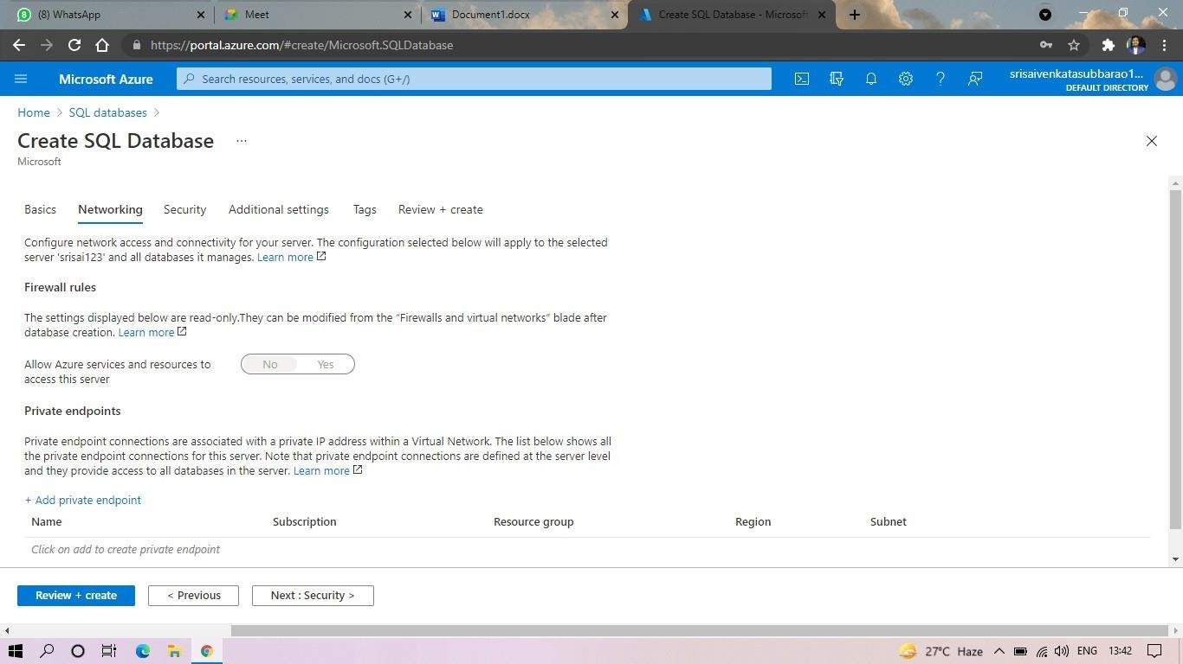

Step5: In Additional Settings Select Sample.

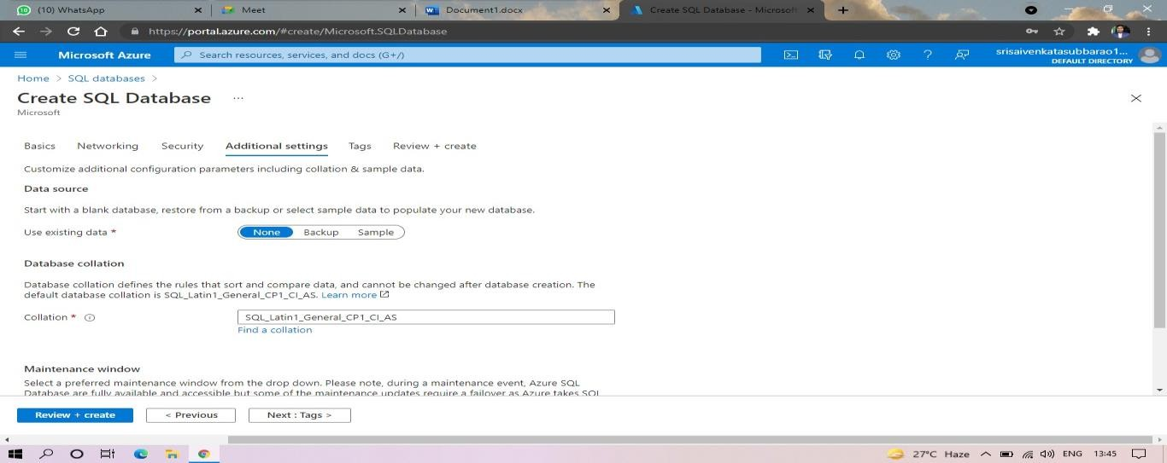

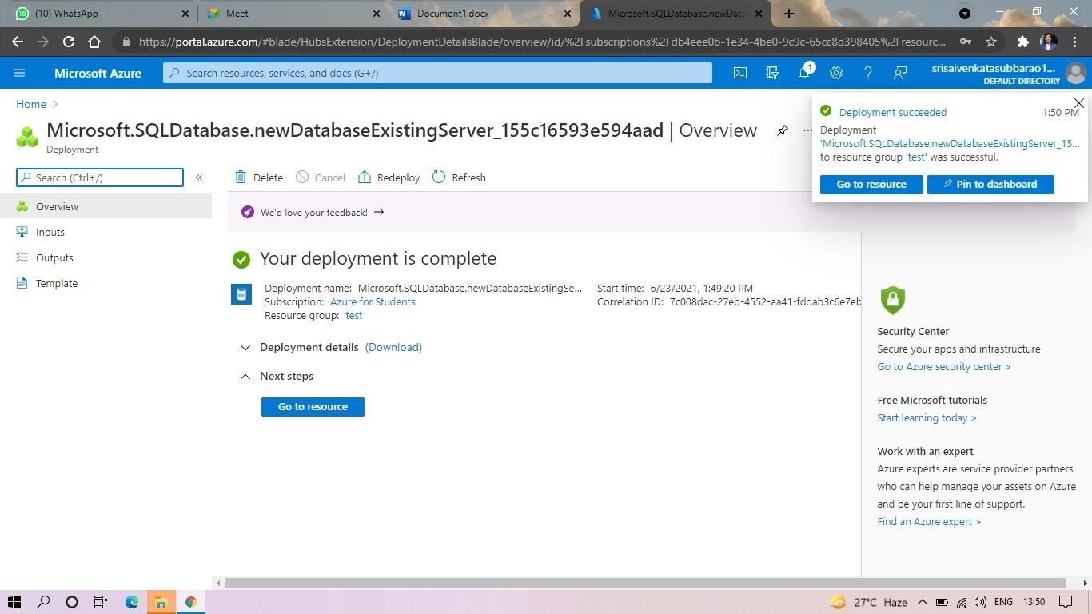
Step6:And The Sql Database Is Deployed.

Step7:And Now Goto Query Editor.
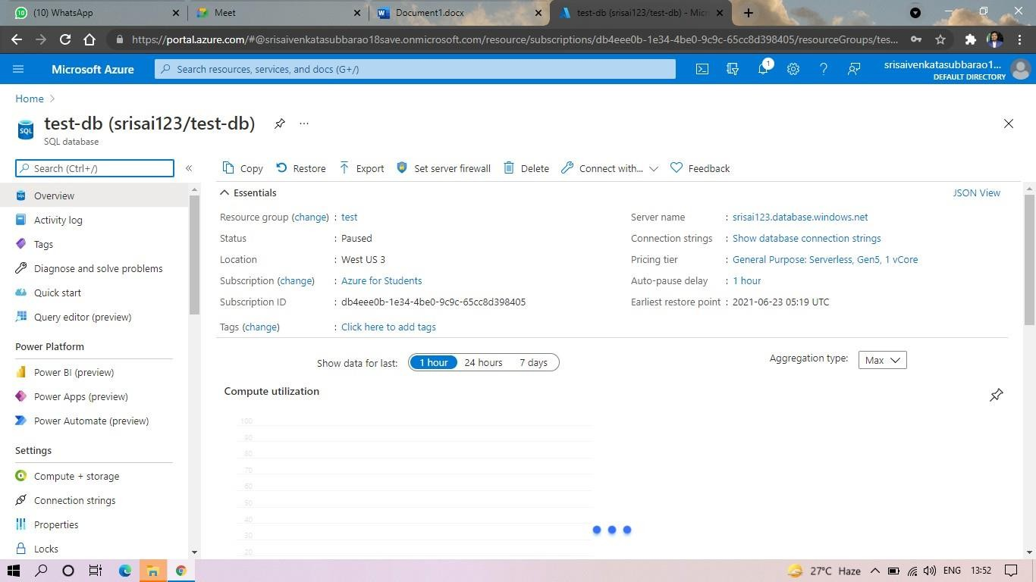

Step8:And Now Again Login To The Sqldatadatabase
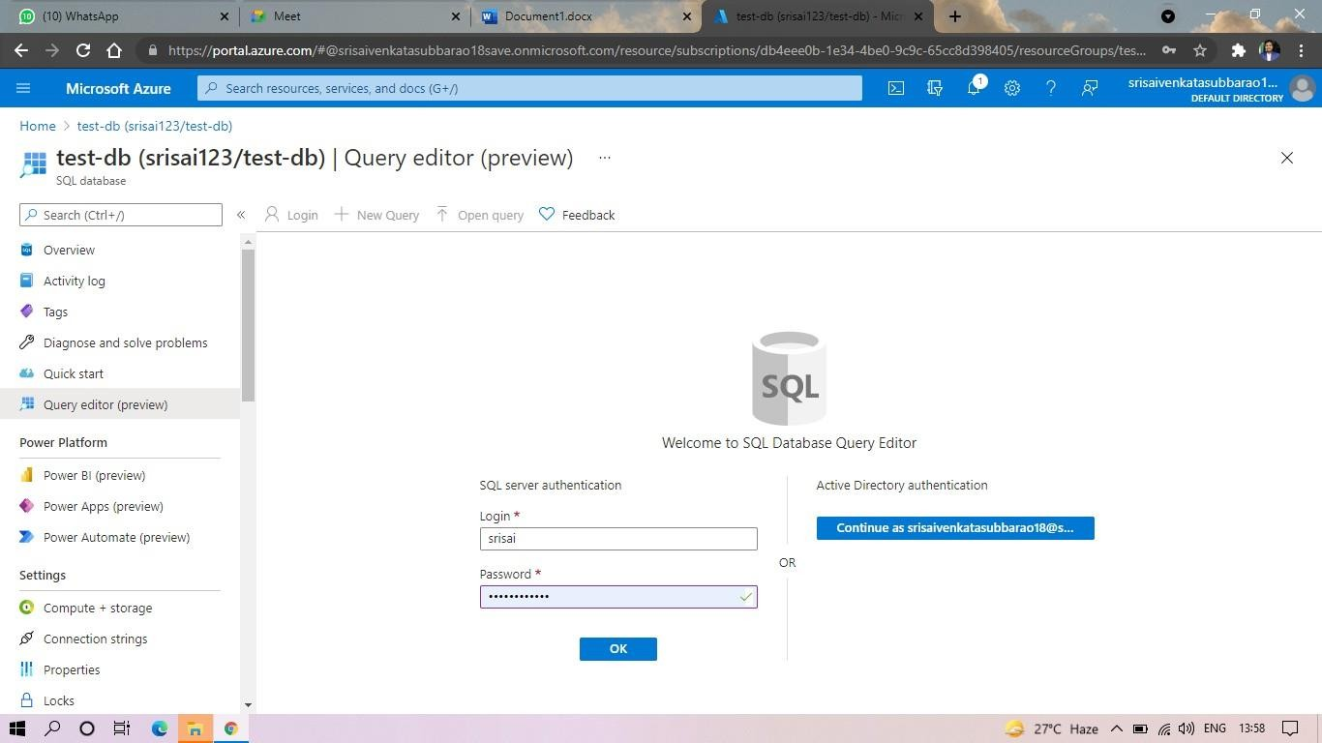

Step9: And Our Tables Will Shown And Type The Query Toexcuted.
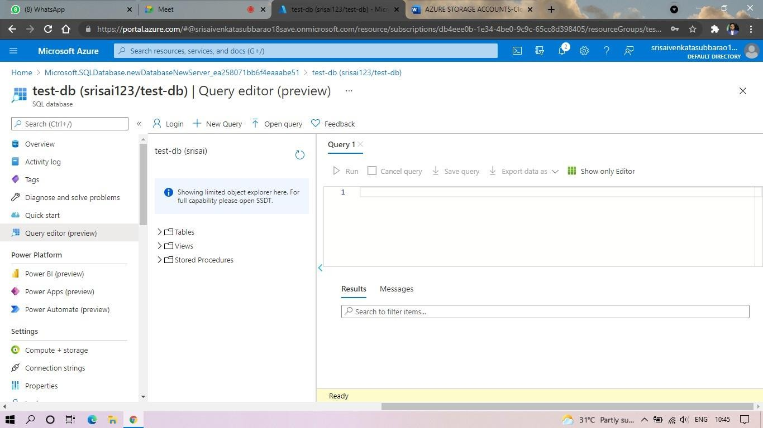

Step10: And Our Output Is Ready.
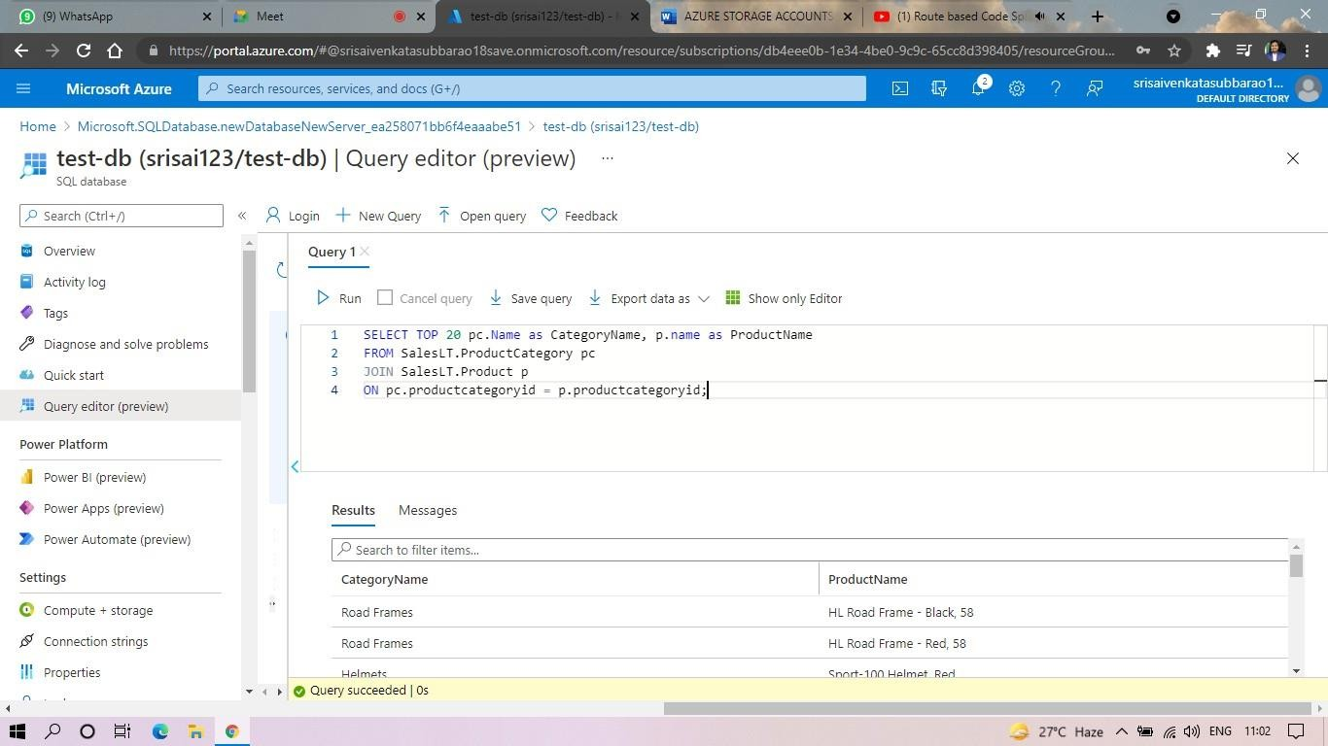

Exp. 22: Perform The Basic Configuration Setup For Installinghadoop 2.X Like Creating The Hduser And Ssh Localhost

Aim: Perform The Basic Configuration Setup For Installinghadoop 2.X Like Creating The Hduser And Ssh Localhost

Procedure:
Step 1 – System Update
$ Sudo Apt-Get Update

Step 2 – Install Java And Set Java_Home
//This First Thing To Do Is To Setup The Webupd8 Ppa On Your System. Run The Following Command And Proceed.
$ Sudo Apt-Add-Repository Ppa:Webupd8team/Java
$ Sudo Apt-Get Update
//After Setting Up The Ppa Repository, Update The Package Cache As Well.
//Install The Java 8 Installer
$ Sudo Apt-Get Install Oracle-Java8-Installer

// After The Installation Is Finished, Oracle Java Is Setup. Run The Java Command Again To Check The Version And Vendor.
[Or]
$ Sudo Apt-Get Install Default-Jdk
$ Java -Version

Step 3 – Add A Dedicated Hadoop User
$ Sudo Addgroup Hadoop

$ Sudo Adduser --Ingroup Hadoop Hduser

// Add Hduser To Sudo User Group
$ Sudo Adduser Hduser Sudo

Step 4 – Install Ssh And Create Certificates
$ Sudo Apt-Get Install Ssh

$ Su Hduser

$ Ssh-Keygen -T Rsa -P ""

// Set Environmental Variables
$ Cat $Home/.Ssh/Id_Rsa.Pub >> $Home/.Ssh/Authorized_Keys

Step 5 – Check If Ssh Works
$ Ssh Localhost

Step 6 – Install Hadoop
// Extract Hadoop-2.7.2
$ Sudo Tar Xvzf Hadoop-2.7.2.Tar.Gz

// Create A Folder ‘Hadoop’ In /Usr/Local
$ Sudo Mkdir –P /Usr/Local/Hadoop

// Move The Hadoop Folder To /Usr/Local/Hadoop
$ Sudo Mv Hadoop-2.7.2 /Usr/Local/Hadoop

// Assigning Read And Write Access To Hadoop Folder
$ Sudo Chown –R Hduser:Hadoop /Usr/Local/Hadoop

Implementation:
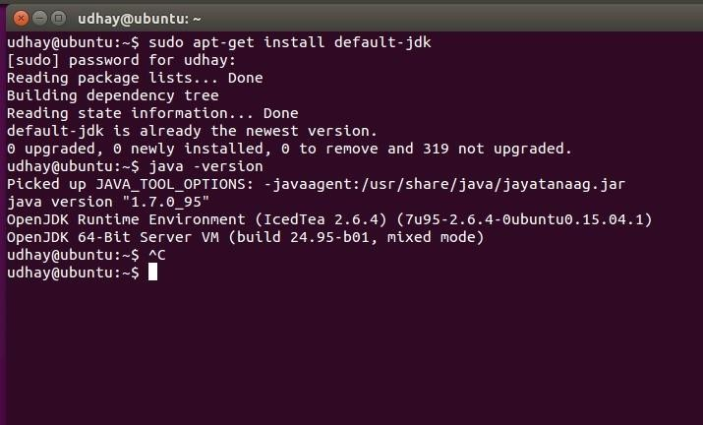

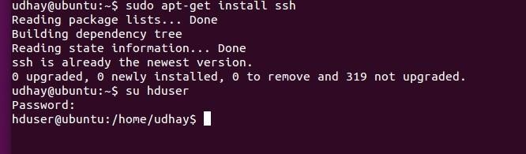
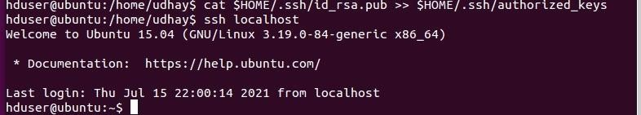
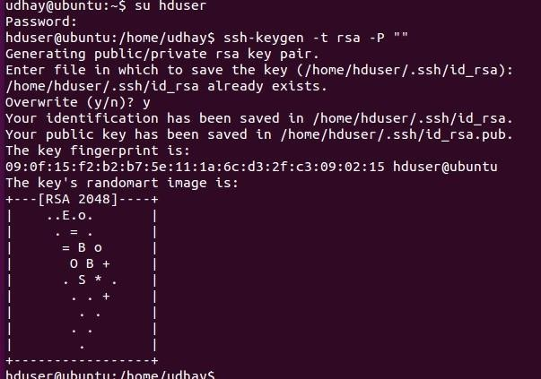

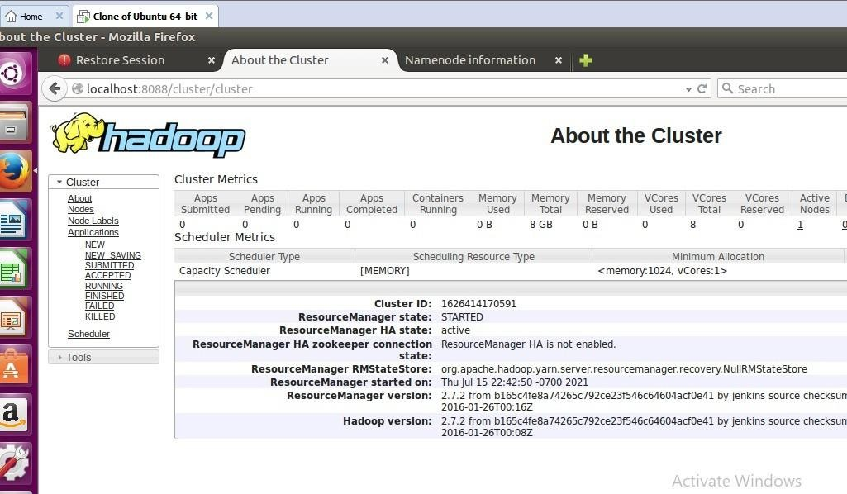

Exp. 23: Install Hadoop 2.X And Configure The Name Node And Datanode.

Aim: Install Hadoop 2.X And Configure The Name Node And Datanode.

Procedure:

Step 7 - Modify Hadoop Config Files
//Hadoop Environmental Variable Setting – The Following Files Will Be Modified

- ~/.Bashrc
- /Usr/Local/Hadoop/Hadoop-2.7.2/Etc/Hadoop/Hadoop-Env.Sh
- /Usr/Local/Hadoop/Hadoop-2.7.2/Etc/Hadoop/Core-Site.Xml
- /Usr/Local/Hadoop/Hadoop-2.7.2/Etc/Hadoop/Hdfs-Site.Xml
- /Usr/Local/Hadoop/Hadoop-2.7.2/Etc/Hadoop/Yarn-Site.Xml
- /Usr/Local/Hadoop/Hadoop-2.7.2/Etc/Hadoop/Mapred-Site.Xml.Template

$ Sudo Nano ~/.Bashrc

// Add The Following Lines At The End Of The File
export JAVA_HOME=/usr/lib/jvm/java-8-oracle
export HADOOP_HOME=/usr/local/hadoop/hadoop-2.7.2 export PATH=$PATH:$HADOOP_HOME/bin
export PATH=$PATH:$HADOOP_HOME/sbin
export HADOOP_MAPRED_HOME=$HADOOP_HOME export HADOOP_COMMON_HOME=$HADOOP_HOME export HADOOP_HDFS_HOME=$HADOOP_HOME
export YARN_HOME=$HADOOP_HOME HADOOP_COMMON_LIB_NATIVE_DIR=$HADOOP_HOME/lib/native export HADOOP_OPTS="-D.java.library.path=$HADOOP_HOME/lib" export PATH=$PATH:/usr/local/hadoop/hadoop-2.7.2/bin

// Configure Hadoop Files
$ Cd /Usr/Local/Hadoop/Hadoop-2.7.2/Etc/Hadoop/
$ Sudo Nano Hadoop-Env.Sh

// Add Following Line In Hadoop-Env.Sh – Set Java Variable In Hadoop
# The java implementation to use.
export JAVA_HOME=/usr/lib/jvm/java-8-oracle

// Create Datanode And Namenode

$ Sudo Mkdir –P /Usr/Local/Hadoop_Tmp/Hdfs/Namenode
$ Sudo Mkdir –P /Usr/Local/Hadoop_Tmp/Hdfs/Datanode
// Changing Ownership To Hadoop_Tmp
$ Sudo Chown –R Hduser:Hadoop /Usr/Local/Hadoop_Tmp
// Edit Hdfs-Site.Xml
$ Sudo Nano Hdfs-Site.Xml
// Add The Following Lines Between <Configuration> …… </Configuration>
<configuration>
<property>
<name>dfs.replication</name>
<value>1</value>
</property>
<property>
<name>dfs.namenode.name.dir</name>
<value>file:/usr/local/hadoop_tmp/hdfs/namenode</value>
</property>
<property>
<name>dfs.datanode.data.dir</name>
<value>file:/usr/local/hadoop_tmp/hdfs/datanode</value>
</property>
</configuration>
// Edit Core-Site.Xml
$ Sudo Nano Core-Site.Xml
// Add The Following Lines Between <Configuration> …… </Configuration>
<configuration>
<property>
<name>fs.default.name</name>
<value>hdfs://localhost:9000</value>
</property>
</configuration>
// Edit Yarn-Site.Xml
$ Sudo Nano Yarn-Site.Xml
// Add The Following Lines Between <Configuration> …… </Configuration>
<configuration>
<property>
<name>yarn.nodemanager.aux-services</name>
<value>mapreduce_shuffle</value>
</property>
<property>

<name>yarn.nodemanager.aux-services.mapreduce.shuffle.class</name>
<value>org.apache.hadoop.mapred.Shuffle-Handler</value>
</property>
</configuration>
// Edit Mapred-Site.Xmsudo
$ Cp /Usr/Local/Hadoop/Hadoop-2.7.2/Etc/Hadoop/Mapred-Site.Xml.Template
/Usr/Local/Hadoop/Hadoop-2.7.2/Etc/Hadoop/Mapred-Site.Xml
$ Sudo Nano Mapred-Site.Xml
// Add The Following Lines Between <Configuration> …… </Configuration>
<configuration>
<property>
<name>mapreduce.framework.name</name>
<value>yarn</value>
</property>
</configuration>
Step-8 – Format Hadoop File System
$ Cd /Usr/Local/Hadoop/Hadoop-2.7.2/Bin
$ Hadoop Namenode -Format

Step 9 - Start Hadoop
$ Cd /Usr/Local/Hadoop/Hadoop-2.7.2/Sbin
// Starting Dfs Services
$ Start-Dfs.Sh
// Starting Mapreduce Services
$ Start-Yarn.Sh
$ Jps
Step 10 - Check Hadoop Through Web Ui
Go To Browser Type Http://Localhost:8088 – All Applications Hadoop Cluster

Go To Browser Type Http://Localhost:50070 – Hadoop Namenode

Step 11 - Stop Hadoop
$ Stop-Dfs.Sh
$ Stop-Yarn.Sh

Implementaion:
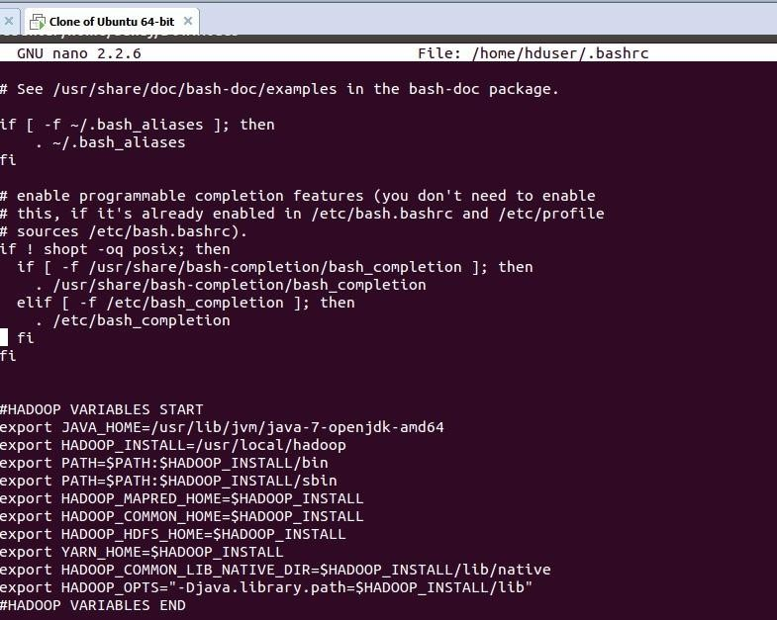
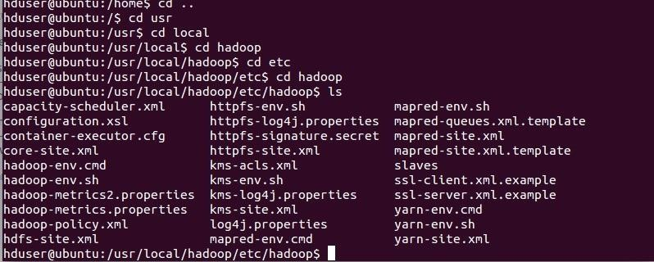

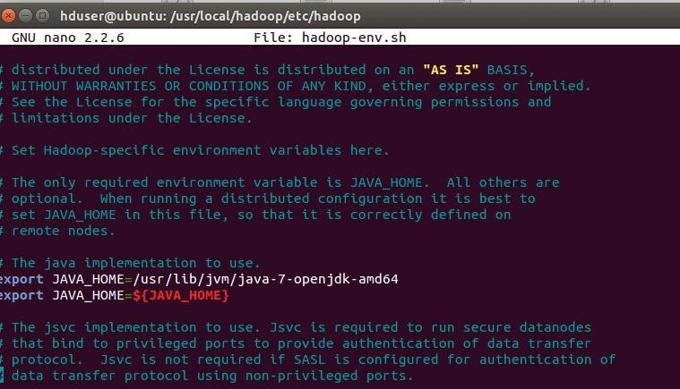
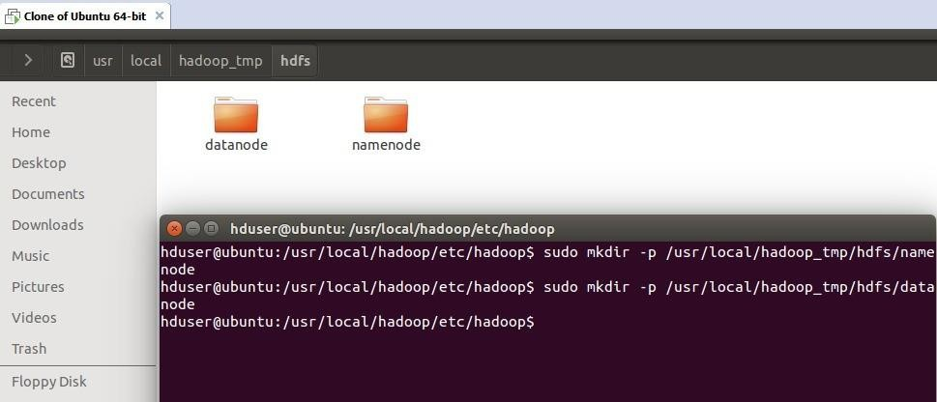

Exp. 24: Launch The Hadoop 2.X And Perform Mapreduce Programfor A Word Count Problem

Aim: Launch The Hadoop 2.X And Perform Mapreduce Programfor A Word Count Problem

Procedure:
Step 1 - Open Terminal
$ Su Hduser
Password:

Step 2 - Start Dfs And Mapreduce Services
$ Cd /Usr/Local/Hadoop/Hadoop-2.7.2/Sbin
$ Start-Dfs.Sh
$ Start-Yarn.Sh
$ Jps

Step 3 - Check Hadoop Through Web Ui

// Go To Browser Type Http://Localhost:8088 – All Applications Hadoop Cluster

// Go To Browser Type Http://Localhost:50070 – Hadoop Namenode

Step 4 – Open New Terminal
$ Cd Desktop/
$ Mkdir Inputdata
$ Cd Inputdata/
$ Echo “Hai, Hello, How Are You? How Is Your Health?” >> Hello.Txt
$ Cat >> Hello.Txt
Step 5 – Go Back To Old Terminal
$ Hadoop Fs –Copyfromlocal /Home/Hduser/Desktop/Inputdata/Hello.Txt /Folder/Hduser
// Check In Hello.Txt In Namenode Using Web Ui
Step 6 – Download And Open Eclipse By Creating Workspace

Create A New Java Project.
Step 7 – Add Jar To The Project
You Need To Remove Dependencies By Adding Jar Files In The Hadoop Source Folder. Now Clickon
Project Tab And Go To Properties.Under Libraries Tab, Click Add External Jars And Select All The

Jars In The Folder (Click On 1st Jar, And Press Shift And Click On Last Jat To Select All Jars In Between And Click Ok)
/Usr/Local/Hadoop/Hadoop-2.7.2/Share/Hadoop/Commonand
/Usr/Local/Hadoop/Hadoop-2.7.2/Share/Hadoop/Mapreduce Folders.
Step -8 – Wordcount Program Create 3 Java Files Named
- Wordcount.Java
- Wordcountmapper.Java
- Wordcountreducer.Java Wordcount.Java
import org.apache.hadoop.conf.Configured; import org.apache.hadoop.fs.Path;
import org.apache.hadoop.io.IntWritable;
import org.apache.hadoop.mapred.FileInputFormat; import
org.apache.hadoop.mapred.FileOutputFormat;import org.apache.hadoop.mapred.JobClient;
import org.apache.hadoop.mapred.JobConf;

import org.apache.hadoop.util.Tool;
import org.apache.hadoop.util.ToolRunner; import org.apache.hadoop.io.Text;

public class WordCount extends Configured implements Tool {@Override public int run(String[] arg0) throws Exception {
// TODO Auto-generated method stubif(arg0.length<2)
{
System.out.println("check the command line arguments");
}
JobConf conf=new JobConf(WordCount.class);
FileInputFormat.setInputPaths(conf, new Path(arg0[0]));
FileOutputFormat.setOutputPath(conf, new Path(arg0[1])); conf.setMapperClass(WordMapper.class);
conf.setReducerClass(WordReducer.class); conf.setOutputKeyClass(Text.class);
conf.setOutputValueClass(IntWritable.class);

}
}

Wordcountmapper.Java
import java.io.IOException;

import org.apache.hadoop.io.IntWritable; import org.apache.hadoop.io.LongWritable;
import org.apache.hadoop.mapred.MapReduceBase; import org.apache.hadoop.mapred.OutputCollector; import org.apache.hadoop.mapred.Reporter;
import org.apache.hadoop.io.Text;
import org.apache.hadoop.mapred.Mapper;

public class WordCountMapper extends MapReduceBase implements Mapper<LongWritable,Text,Text,IntWritable>
{
@Override
public void map(LongWritable arg0, Text arg1, OutputCollector<Text, IntWritable> arg2, Reporter arg3)

Wordcountreducer.Java
import java.io.IOException;import java.util.Iterator;
import org.apache.hadoop.io.IntWritable; import org.apache.hadoop.mapred.JobConf;
import org.apache.hadoop.mapred.OutputCollector; import org.apache.hadoop.mapred.Reducer;
import org.apache.hadoop.mapred.Reporter; import org.apache.hadoop.io.Text;

public class WordCountReducer implements Reducer<Text,IntWritable,Text,IntWritable> { @Override
public void configure(JobConf arg0) {

}
@Override
public void reduce(Text arg0, Iterator<IntWritable> arg1, OutputCollector<Text, IntWritable> arg2, Reporter arg3)
throws IOException {
// TODO Auto-generated method stubint count=0;
while(arg1.hasNext())
{
IntWritable i=arg1.next(); count+=i.get();

Step 9 - Creatr Jar File
Now Click On The Run Tab And Click Run-Configurations. Click On New Configuration Button On The Left-Top Side And Apply After Filling The Following Properties.
Step 10 - Export Jar File

Now Click On File Tab And Select Export. Under Java, Select Runnable Jar.

In Launch Config – Select The Config Fie You Created In Step 9 (Wordcountconfig).

Select An Export Destination (Lets Say Desktop.)
Under Library Handling, Select Extract Required Libraries Into Generated Jar And Click Finish.
Right-Click The Jar File, Go To Properties And Under Permissionstab, Check Allow Executingfile As A Program. And Give Read And Write Access To All The Users

Step 11 – Go Back To Old Terminal For Execution Of Wordcount Program

$Hadoop Jar Wordcount.Jar/Usr/Local/Hadoop/Input/Usr/Local/Hadoop/Output
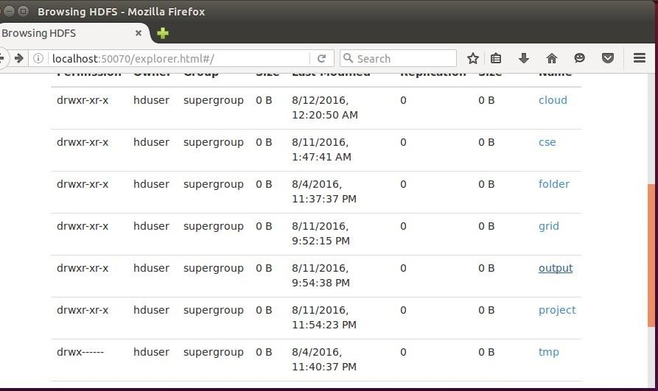

Step 12 – To View Results In Old Terminal

$Hdfs Dfs -Cat /Usr/Local/Hadoop/Output/Part-R-00000
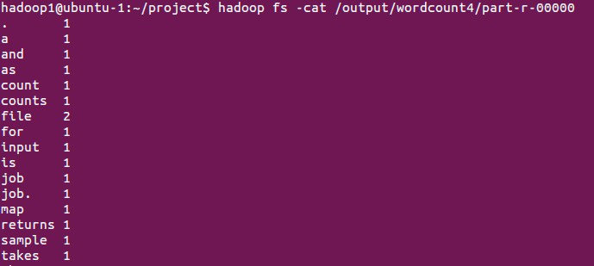
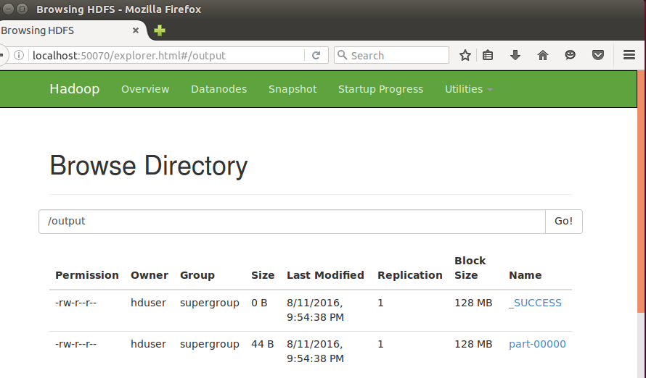

Step 13 - To Remove Folders Created Using Hdfs

$ Hdfs Dfs -Rm -R /Usr/Local/Hadoop/Output

